# Laboratory 2

**Boolean Expressions using Universal Gates**

1. Introduction and Purpose of Experiment

Students will learn to simulate and implement logic circuits using only universal gates.

1. Aim and Objectives

**Aim:** To simulate and implement logic circuits using only NAND and NOR gates

**Objectives:** At the end of this lab, the student will be able to

* Use Logisim to simulate Boolean circuits using only NAND gates
* Describe the procedure to convert all the gates in a circuit to universal gates
* Draw circuit diagrams for Boolean expressions using only universal gates

1. Experimental Procedure
   1. Draw truth tables and circuit diagrams for the following expressions using only NAND gates.
 $F=AB+CD$

 $F=X\sim Y+\sim XY+Z$

 $F =A(CD+B)+BC$

$F=AB+BC+AC$

2. Draw truth tables and circuit diagrams for the following expressions using only NOR gates.
 $F = (A + B)(C + D)E$

 $F=(A+B+C)(\sim A+\sim B+\sim C)$

 3. Use Logisim to generate truth tables and circuit diagrams for the expressions in 3(a).
   4. Implement the first three expressions in the non-minimized form and verify the truth tables. Show the output to the course leader.
   5. Why is it easier to draw a circuit diagram using universal gates if the Boolean expression is in standard/canonical form?

Your document should include:

* Handwritten truth tables and circuit diagrams for the expressions
* Logisim screenshots
* Answer to 3(e)

**Solutions:**

1.

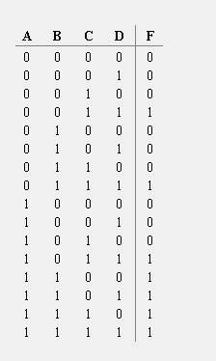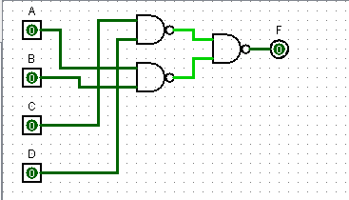

2.

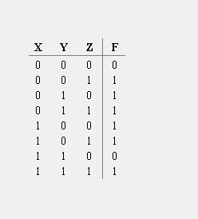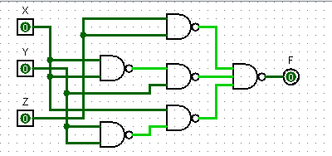

3.

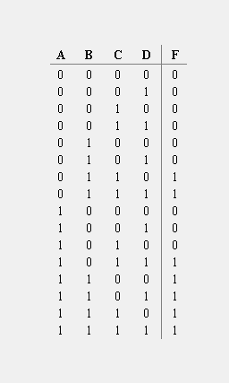

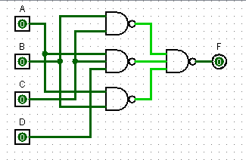

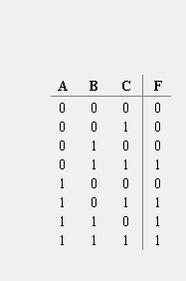4.

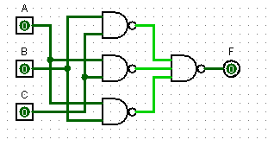

5.

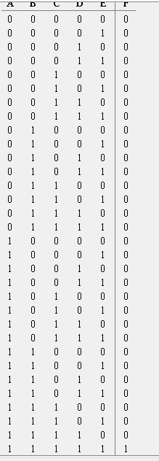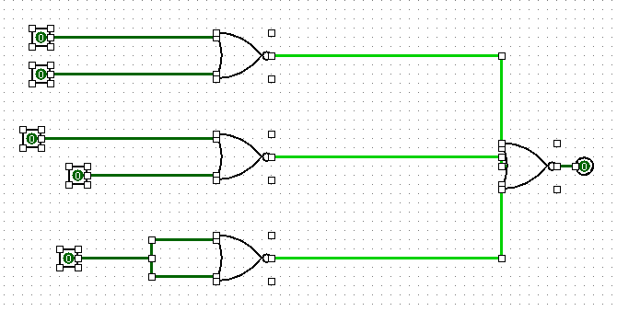

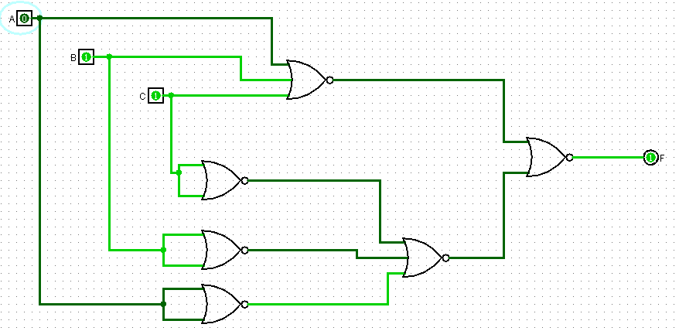6.

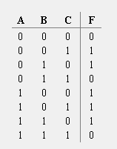

# Laboratory 3

**Gate Level Minimization using Karnaugh Maps**

1. Introduction and Purpose of Experiment

Students will learn to minimize Boolean Expressions using K-Maps and then simulate and implement them.

1. Aim and Objectives

**Aim:** To apply K-Maps to minimize Boolean expressions

**Objectives:** At the end of this lab, the student will be able to

* Apply K-Maps to simplify three- and four-variable Boolean Expressions
* Implement minimized expressions using basic and universal gates

1. Experimental Procedure
   1. Minimize the following expressions using K-Maps.
 $F(A,B,C)=∑(1,3,5,7)$

 $F(A,B,C,D)=∑(0,2,3,7,11,13,14,15)$

 $F(A,B,C)=∑(2,3,4,5)+ϕ(6,7)$

$F=\sim A\sim B\sim C\sim D+A\sim C\sim D+\sim BC\sim D+\sim ABCD+B\sim CD$

$F(A,B,C,D)=∏(1,3,5,7,13,15)$

$F(A,B,C,D)=∏(1,3,6,9,11,12,14)$

$F=\left(\sim A+B+\sim D\right).\left(\sim A+\sim B+\sim C\right).\left(\sim A+\sim B+C\right).(\sim B+C+\sim D)$

2. Draw truth tables and circuit diagrams for the minimized expressions in 3(a) considering:

* 3(a) 2: Use basic gates
* 3(a) 3 and 3(a) 4: Use NAND gates
* 3(a) 5: Use basic gates
* 3(a) 6 and 3(a) 7: Use NOR gates
  1. Use Logisim to generate truth tables and circuit diagrams for the expressions in 3(a)2 to 3(a)5.
  2. Implement the minimized expressions of 3(a)4 to 3(a)6. Show the output to the course leader.
  3. With an example, show why incorrect grouping in K-Maps may result in a non-minimized expression

Your document should include:

* Handwritten truth tables and circuit diagrams for the expressions
* Logisim screenshots
* Answer to 3(e)

**Solutions:**

**3(a)2.**

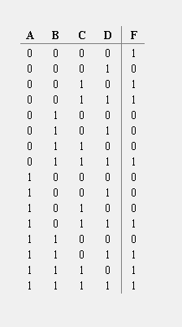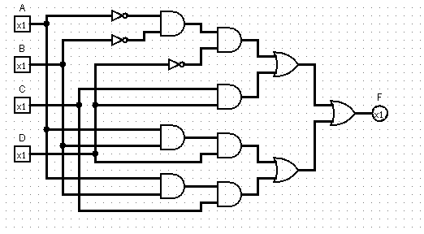

**3(a)5.**

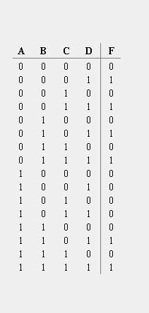

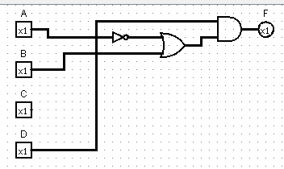

# Laboratory 4

**Code Conversion Circuits**

1. Introduction and Purpose of Experiment

Students will learn to design, simulate and implement circuits for various code converters.

1. Aim and Objectives

**Aim:** To generate code words using various codes and convert them from one code to another

**Objectives:** At the end of this lab, the student will be able to

* Develop expressions that convert code words from one code to another
* Develop code converter circuits

1. Experimental Procedure
   1. Write truth tables for the following code converters.
      1. BCD to Gray
      2. Gray to BCD
      3. 4-bit BCD to Excess-3
   2. Use K-Maps to develop the minimized expressions for the above code converters
   3. Draw the circuit diagrams using the following gates:
      1. Binary to Gray: Using NAND gates
      2. Gray to BCD: Using Ex-OR gates
      3. 4-bit BCD to Excess-3 using Basic Gates
   4. Use Logisim to generate truth tables and circuit diagrams for all the code converters.
   5. Implement the code converters and show the output to the course leader.
   6. Show in detail how adders and subtractors are useful in developing these code converters.

Your document should include:

* Handwritten truth tables, expressions and circuit diagrams for the code converters
* Logisim screenshots
* Answer to 3(h)

**Solutions:**

**3.A.1**

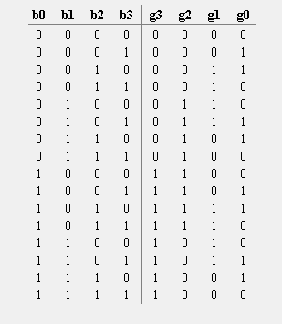

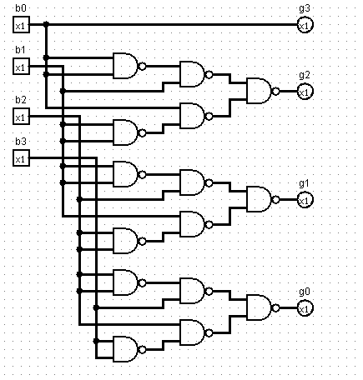

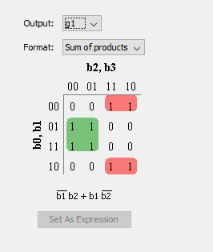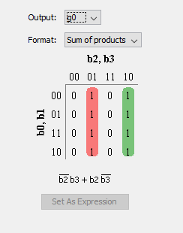

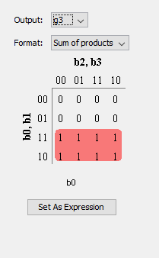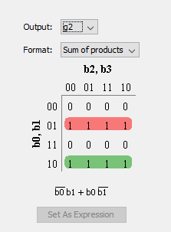

**3.A.2**

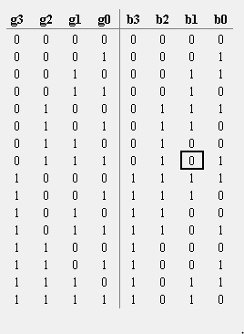

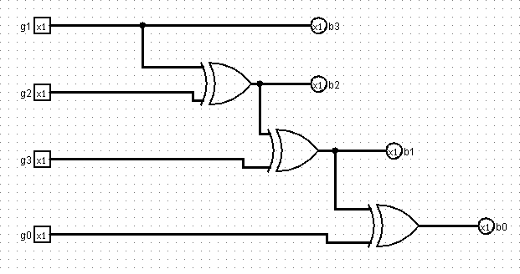

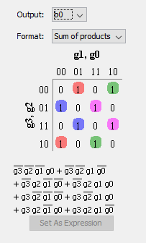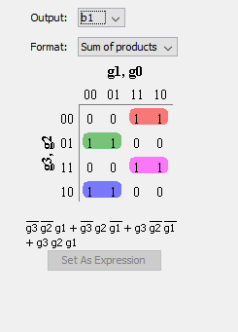

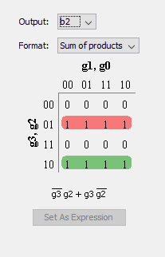

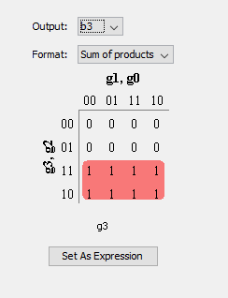

**3.A.3**

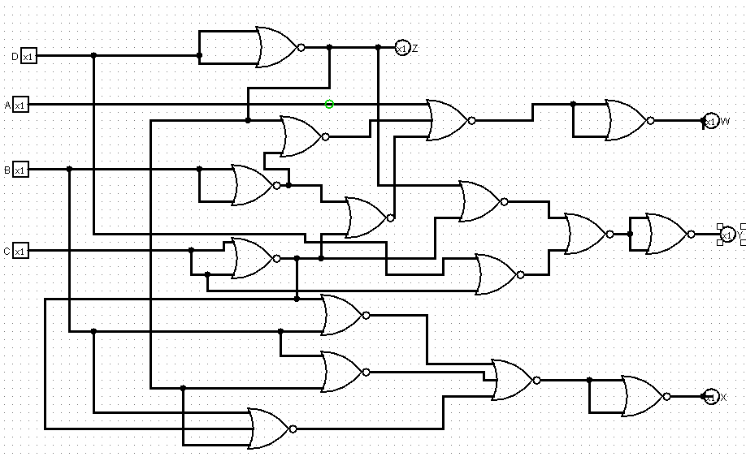

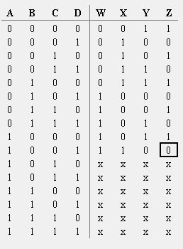

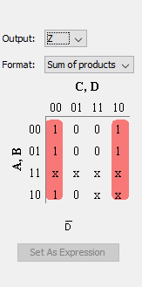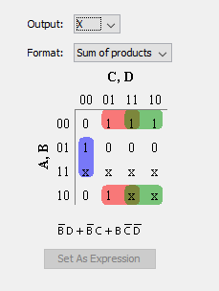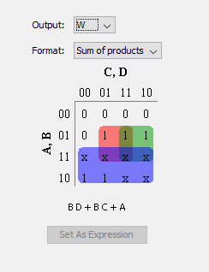

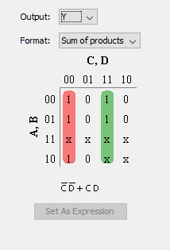

# Laboratory 5

**Combinational Circuits-I**

**Adders and Subtractors**

1. Introduction and Purpose of Experiment

Students will learn to design, simulate and implement adders and subtractors.

1. Aim and Objectives

**Aim:** To use adders and subtractors and perform mathematical operations on binary numbers

**Objectives:** At the end of this lab, the student will be able to

* Add and subtract 4-bit binary numbers
* Use adder circuits to perform subtraction

1. Experimental Procedure
   1. Write truth tables, Boolean expressions and circuit diagrams for the following combinational circuits:
      1. Half and full adder
      2. Half and full subtractor
   2. Using 4 full adders and other additional circuitry, design a circuit capable of adding and subtracting two 4-bit numbers.
   3. Use Logisim to simulate the circuit designed above.
   4. Implement the circuit and show the output to the course leader.
   5. Show in detail how a full adder can be implemented using two half adders.

Your document should include:

* Handwritten truth tables, expressions and circuit diagrams for the combinational circuits in 3(a).
* Design of the circuit
* Logisim screenshots of the designed circuit
* Answer to 3(e)

**Solutions:**

**Half - Adder:**

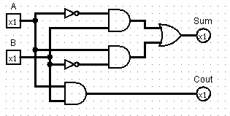 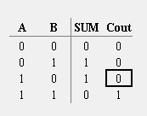

**Full - Adder:**

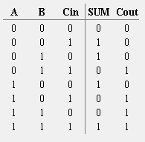

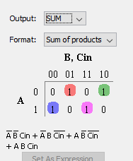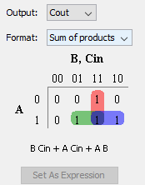

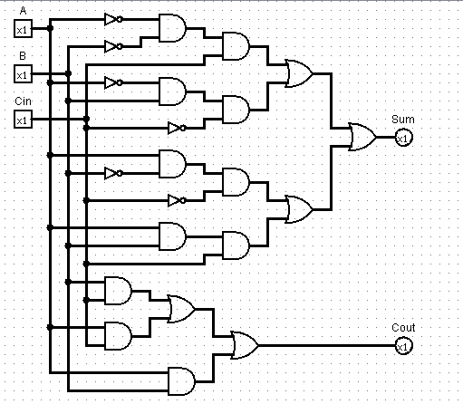

**Half- Subtractor :**

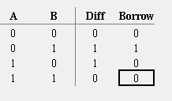 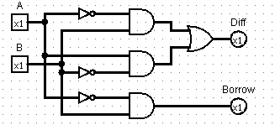

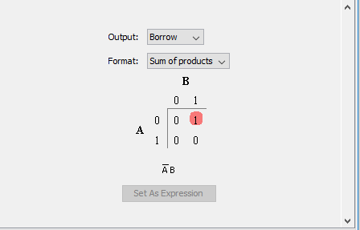 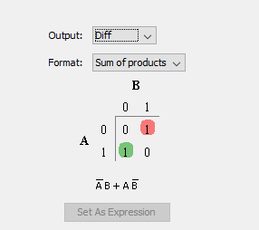

**Full - Subtractor :**

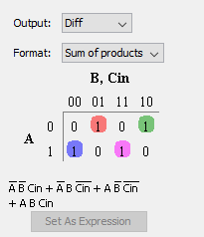 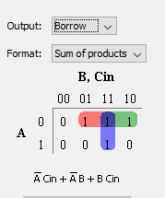

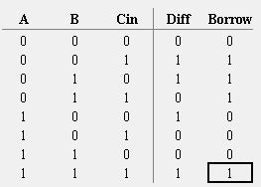

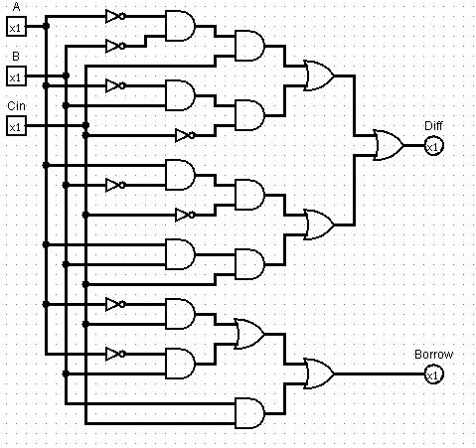

# Laboratory 6

**Combinational Circuits-II**

**Multiplexers and Demultiplexers**

1. Introduction and Purpose of Experiment

Students will learn to design, simulate and implement circuits using Multiplexers and Demultiplexers.

1. Aim and Objectives

**Aim:** To verify functionality of Mux and Demux and use Multiplexer to implement Boolean functions

**Objectives:** At the end of this lab, the student will be able to

* Verify the functionality of Mux and Demux
* Use Multiplexers to implement given Boolean Functions

1. Experimental Procedure
   1. Write truth tables and block diagrams for
      1. 4 to 1 Multiplexer
      2. 8 to 1 Multiplexer
      3. 1 to 4 Demultiplexer
      4. 1 to 8 Demultiplexer
   2. Construct the circuits for 3 (a) (I) to 3 (a) (IV) above using appropriate ICs. Verify the functionality and show the output to the course leader
   3. Use Logisim to simulate the circuits designed above.
   4. Using an example, show how any Boolean Expression in SoP form can be implemented using a Multiplexer. Simulate the same using Logisim.

Your document should include:

* Handwritten truth tables and block diagrams for the circuits in 3(a).
* Logisim screenshots of all the Multiplexers and Demultiplexers.
* Answer to 3(d)
* Logisim screenshots for 3(d)

# Laboratory 7

**Combinational Circuits-III**

**Decimal to BCD Encoder and Decoders**

1. Introduction and Purpose of Experiment

Students will learn to design and implement a circuit for Decimal to BCD Encoder.

1. Aim and Objectives

**Aim:** Design and implement a circuit for Decimal to BCD Encoder

**Objectives:** At the end of this lab, the student will be able to

* Develop a circuit for Decimal to BCD Encoder
* Understand the basics of Decoders

1. Experimental Procedure
   1. Write truth table and block diagram for Decimal to BCD Encoder
   2. Construct the circuits for Decimal to BCD Encoder using appropriate ICs. Verify the functionality and show the output to the course leader
   3. Using an example, describe how a decoder can be implemented using a Demultiplexer.

Your document should include:

* Handwritten truth table and block diagrams for the circuit in 3(a).
* Answer to 3(c)